English Language & Literature 10
War Poetry & Propaganda
Formative Assessment: Oral + Visual Poem Analysis

Key Concept: Creativity
Global Context: Personal and Cultural Expression
Statement of Inquiry: Profound human emotion can be powerfully expressed through creative genres.

Poetry, although written, is a very visual art form; a poet relies heavily on figurative language, like imagery, to create images in readers’/listeners’ minds and convey his/her ideas.

GOAL: Your goal is to use the analytical and oral communication skills to closely examine and analyze a poem from World War One.

AUDIENCE: You are speaking to your classmates and your teacher to express your ideas about a poem. Your register should be formal.

PRODUCT:

You will give an oral presentation that shows your understanding and interpretation of a WW1 poem. Your interpretation must be supported with textual evidence and an analysis of language used in the text to create meaning. You will also submit a written analysis of your chosen lines (1 page).

STEPS:

You will need to choose a poem written during WW1 (NOT one already studied in class), annotate it, and decide WHAT you believe the poet is trying to convey through the poem, and HOW his/her message is conveyed through language.

Choose 2-3 lines (that occur consecutively/together) from the poem that really stand out to you, and create or find an image to represent these lines.

You will read the entire poem to the class, then share your chosen image paired with the lines and explain why you chose this image and how it convey the poet’s overall meaning.

*TIP: The image does not have to be literal. Think symbolically, thematically, and metaphorically. Consider tone, figurative language, punctuation, structure…The strongest analyses will not rely on literal images of the “action”, but will rather showcase the poem’s “big ideas”.

PRESENTATION REQUIREMENTS:
- Read your poem & project it on the screen for the class to follow along
- 1 image (original or from the internet – with source if the latter)
- 2-3 lines that relate to the images
- Strong analytical interpretation of links between language used by the poet, image, and meaning
- 1-page written analysis submitted on Turn It In on the presentation day

STANDARDS & CRITERIA FOR SUCCESS (You will be assessed using the following criteria):
MYP criteria: | Task-specific clarifications:
Criterion A: Analyzing  i. analyse the content, context, language, structure, technique and style of text(s) and the relationship among texts  ii. analyse the effects of the creator’s choices on an audience  iii. justify opinions and ideas, using examples, explanations and terminology | Criterion A: Analyzing  i.discuss the ‘action’, themes, structure, and literary & stylistic features of the poem and explore how the choices made by the poet create a clear meaning and link to the purpose of the poem. Explain image choices.  ii. discuss the effects of the literary and stylistic features on the audience  iii. support all points with specific evidence from the text, using specific literary terms learned (imagery, metaphor, connotative diction, assonance, etc.), and explain all examples fully
Criterion D: Using Language  i. Use a range of appropriate vocabulary, sentence structures and forms of expression.  ii. Speak in a consistently appropriate register and style that serve the context and intention.  iv. pronounce with accuracy  v. use appropriate non-verbal communication techniques | Criterion D: Using Language  i. Vary your vocabulary to avoid repetition and to strengthen ideas, including figurative language terms.  ii. Use a formal language register that is suitable to a formal presentation. Project your voice and speak clearly.  iv. Practice reading poem and pronouncing difficult terms to ensure clarity  v. Make eye contact with the audience; maintain composure and proper body language to engage your audience and avoid distracting behavior.

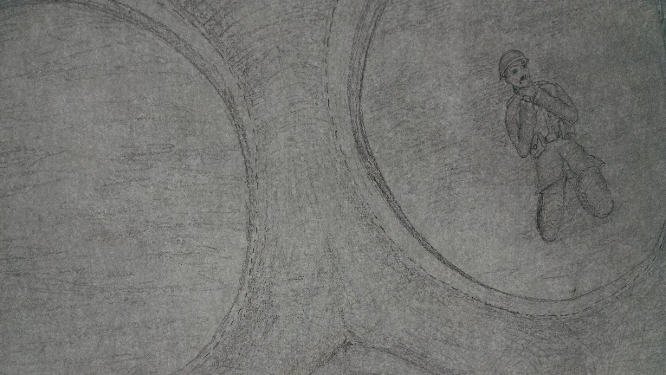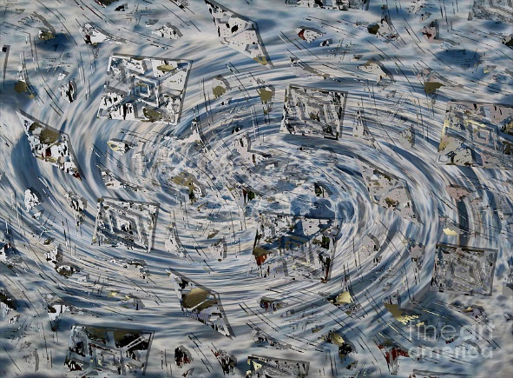
As under a green sea, I saw him drowning.
In all my dreams, before my helpless sight,
Dulce et Decorum Est, Wilfred Owen
Image by Grade 10 Student, 2015 “Whirlwind” by J. Burns
An ecstasy of fumbling,
Dulce et Decorum Est, Wilfred Owen

Dulce et Decorum Est, Wilfred Owen

